Note
Subject | : | Greenhouse Gas Inventory (2023)
Prepared by | : | Camilla Kaasing Trolle (CKT)
Date | : | 17-04-2024

2023 Greenhouse Gas inventory for ProCon Group
Contents
Introduction 1
1. The Greenhouse Gas Protocol 1
2. Organizational mapping 2
3. Data collection 3
4. Results 4
5. Limitations 5

Introduction

This note presents the results of the 2023 Greenhouse Gas (GHG) inventory for ProCon Group (ProCon). Due to an increased focus on sustainability, ProCon decided in 2022 to conduct their first ever GHG account, which makes this the company’s second GHG account. Therefore, the presented results in this note are to be looked upon as a stage of development, structuring and implementing ProCon’s intentions for future GHG reporting. Initiation of a data collection structure has been a focus point in this 2023 GHG inventory and the process will continue towards ProCon’s 2024 GHG inventory, as initiatives have been launched. A Further focus point in the 2023 inventory is to identify which main areas of the companies activities creates the largest CO2 emissions.

The inventory has been performed by the use of the platform Klimakompasset - a tool created by the Danish Business Authority in collaboration with the the Danish Energy Agency. Klimakompasset is based on the principles of the GHG Protocol, which is the global standard for GHG accounting.

1. The Greenhouse Gas Protocol

The GHG Protocol is an extensive and global standard that provides guidance on how to manage and account for emissions of greenhouse gasses (GHGs) in public and private sectors. The GHG protocol includes emission from own activities (scope 1 and 2), emission from value chains (scope 3), as well as potential mitigating measures.

- Scope 1: Includes direct emissions generated from the company’s own activities i.e., from its own localities and assets (e.g., emissions from combustion of diesel, petrol and gas).

- Scope 2: Includes the indirect emissions released from the production of externally produced energy used by the company for its operations (e.g., energy purchased from electricity provider or district heating).

- Scope 3: Includes indirect emissions from the value chain in which the company participates (e.g, emissions from procurements of goods and services, employee commuting and business travels, and transport of materials and goods)

2. Organizational mapping

When reporting following the GHG protocol the first step is to determine the organizational boundaries within which to scope the reporting. These can take the form of equity share approach (where you include entities based on your share of equity) or control approach (where you report on operations over which you have control). Since ProCon both owns and control all entities included in the present inventory both the equity share approach and the control approach have been applied (in accordance with the GHG Protocol).

The company consists of multiple subsidiaries under ProCon Group and is headquartered in Denmark with operations in three Danish offices (in the cities of Aalborg, Aarhus, and Esbjerg). Additionally, ProCon has an office incl. staff in Taiwan and UK to manage local projects. Further international representation with company registrations in Germany (DE), Poland (PL), the US (US) and ProCon Technic (DK) from which no significantly emitting activities have been performed in 2023.

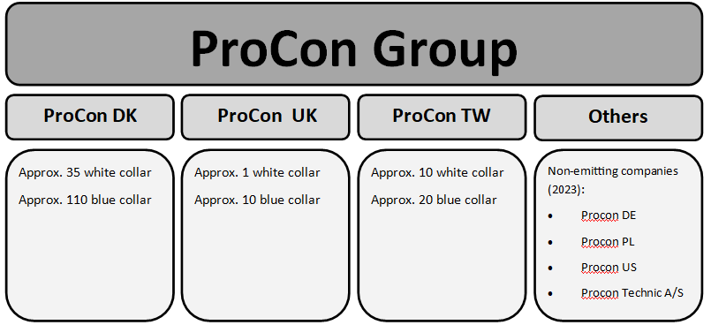

Figure 1 - Organizational diagram

3. Data collection

Data collected for the 2023 GHG inventory consist of data from ProCon DK, Procon UK and Procon TW, as illustrated in figure 1.

The input data used for the CO2e-calculations comes from a variety of sources. The methodology followed a combination of the methods described in the GHG protocol. Table 1 presents four methods for collecting data and obtaining emission factors:

Data collection methods
Supplier-specific method: Product-level cradle-to-gate GHG inventory data from goods and services suppliers (product-specific emission factor).
Hybrid method: Combines available supplier-specific data (such as product specific emission factors) with secondary data to fill in the gaps.
Average-data method: The mass of purchased goods (e.g., kg) or other relevant units of goods and services are multiplied with relevant secondary emission factors (e.g., sector-average emission factors).
Spend-based method: The monetary value of purchased goods and services is multiplied with relevant secondary emission factors (e.g., sector-average emission factors).
Table 1 - Data collection methods

For ProCon’s 2023 GHG account, the data and emission factors have been collected using the hybrid, average-data, and spend-based methods. Since the core component of ProCon’s business is to provide varying services related to wind farm projects, the material input and associated supply chains vary from project to project, making the supplier-specific method ineffective as no standardized product/service is being provided continuously across the organization’s projects.

The primary data collection method for ProCon’s 2023 GHG account is the spend-based method.
The data collected for ProCon’s 2023 GHG inventory has been split into project related costs and non-project related costs. The project related costs were subsequently divided into suppliers after which the suppliers have been categorised based on the products or services they supply. Non-project related costs have been collected from ProCon’s P&L, where relevant accounts have been categorised based on the entering on these accounts. Some project related and non-projected costs have afterwards been investigated further and consumption units has been estimated or specific emission factors has been found:
- Scope 1:
  - Emissions from transportation in ProCon’s own or leased vehicles: Based on the monetary value spend on fuel an estimated consumption of litres of diesel was calculated. This calculation was made based on an average market price of diesel in Denmark in 2023.
- Scope 2:
  - Electricity and district heating: ProCon’s consumption of electricity and district heating are reported in KWh and MWh. For the 2023 GHG inventory, only scope 2 emissions from the Danish locations have been included, due to lack of readily available data from ProCon TW and assessed insignificant emissions from PWE UK.
Unfortunately, it has not been possible to obtain the actual consumed units in 2023. Therefore, consumption units have been estimated based on advance payments.
- Scope 3:
  - Materials: For purchased lamps and electrical panels representative emission factor for comparable products are used.
For purchased tools – hand tools and power tools/machines, representative emission factors from databases are used since these are not available in Klimakompasset.
  - Flight: ProCon purchases flight tickets through an agency as well as directly at the airlines. The agency provides a report of the Co2-emission related to the flights purchased through them. This data has been used to estimate an emission factor per. spent DKK, which subsequent has been used to estimate the emission from the flights purchased directly at the airlines.
  - Freight: Emission from freight is calculated proportionately based on ScanGlobal's emissions from freight distributed per turnover DKK in 2023.

4. Results

The result of the 2023 GHG inventory is presented in table 2. CO2e-emissions are stated in tons of CO2 equivalents, and the table shows the emission divided into scope 1, 2 and 3 in accordance with the GHG protocol.

Scope | Ton CO2e | Share of emission
Scope 1 | 129,29 | 4,6%
Scope 2 | 1,52 | 0,1%
Scope 3 | 2.659,75 | 95,3%
Total | 2.790,56 | 100,0%
Table 2 - Overview of the company's total CO2e emissions

In the spot analysis in chart 1 below, ProCon's 20 largest sources of emissions are shown.

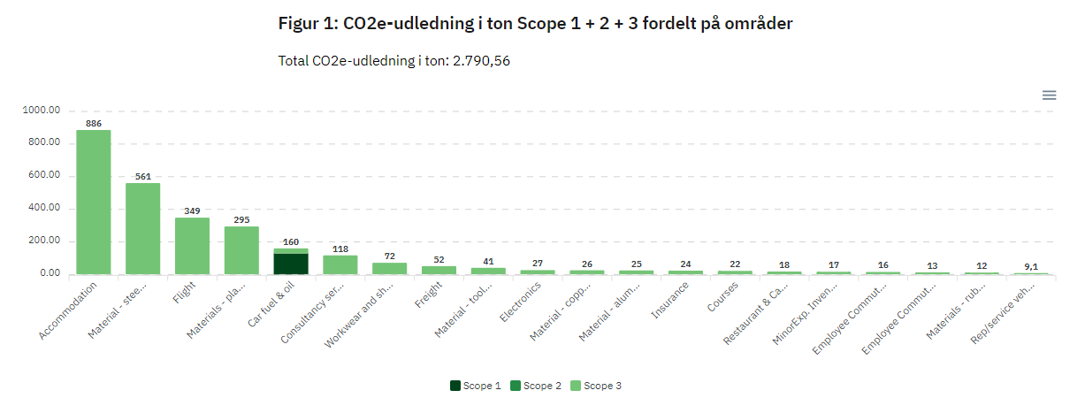
Chart 1 - CO2e-emmision from scope 1 + 2 + 3 divided into areas

As shown in chart 1 ProCon's largest source of emissions is accommodation, which is primarily related to the travel work carried out by blue collar employees. In that relation, chart 1 also shows that ProCon's 3rd largest emissions are flights, which is primarily related to the blue collar employees travelling to and from worksites. Materials/consumables procured are distributed over several separate entries, but still stands out as a significant source of emissions – especially purchased materials/consumables made of steel and plastic.

5. Limitations and uncertainties

It is acknowledged that the 2023 GHG account is the second time for ProCon to disclose their GHG emissions and that there are certain limitations to the results of the account.

No data collecting systems targeted at capturing GHG-related data are integrated in the existing processes of ProCon, which means that all relevant data could not always be readily obtained. The strategy used to mitigate this issue has been to combine different data-collecting methodologies presented in table 1.

The variety of ProCon’s purchased goods and services results in great complexity in its supply chains. Depending on the scoping and terms of references outlined for each project, the types of procured goods and services vary between projects, making it difficult to track – especially for smaller parts (consumables) like nuts, screws, bolts, and wires. As no systematic registration of such purchases exists across the organization, it has not been possible to obtain all the necessary input data, by which it has been necessary to scope out some of the materials/consumables purchased in the 2023 GHG account. In order to improve the quality and obtainability of the necessary input data for future GHG accounts, ProCon is committed to improving its data registration systems over the coming years.

ProCons emission in relation to accommodation is associated with some uncertainty, since the Spend-based method has been used. A more accurate emission would be obtained if it was possible to identify emission factors for each overnight stay in each country, given that the emission from one overnight stay differs significantly from country to country. Unfortunately is has not been possible to identify emission factors for each country that ProCon operates in and therefore the Spend-based method has been used.

